Table of Contents
NO. | CHAPTER | PAGE
1 | Overview of C++ | 1
2 | Need for the Project | 3
3 | Requirements (Hardware & Software) | 4
4 | Header Files (Used in the project) | 5
5 | Classes and Objects (Member Variables and Member Functions) | 7
6 | Non Member Function | 12
7 | System Flow Diagrams | 13
8 | E – R Diagram | 14
9 | Source Code | 15
10 | Screen shots | 28
11 | Future Enhancement | 33
12 | Bibliography | 34

Overview Of C++

- C++ is a language which support object oriented programming. Object oriented programming language programs are easy to develop and easy to maintain. Object oriented analysis and design is an upcoming technology that software professional have employed successfully in the development of large software project.
- C++ is an extension of C- Language that is widely used on many machines. It is powerful modern language that combines the power; elegance and flexibility of C and the feature of object oriented programming. With it’s object oriented capability such as data abstraction, inheritance and polymorphism.
- C++ offer significant software engineering benefit over C. C++ supports both OOP & structured programming. It gives the easiest way to handle the data hiding and encapsulation with the help of powerful keywords such as class, private, and public and protected.
- Inheritance, one of most powerful design concept is supported with single inheritance and multiple inheritances of base classes and derived classes. Polymorphism through virtual functions, virtual base classes and virtual distracters gives the late binding of the compiler. C++ because on function and class templates for handling parameterized data type.

OOPs & Benefits of using OOPs

- OOP ( Object- oriented programming ) is a popular technique supported by most of recent languages.
- It is a set of software engineering tools that can be used to build more reliable and reusable system. Object-oriented programming as a paradigm is playing an increasingly significant role in the analysis, design and implementation of software systems.
- Provides the ability to create class hierarchies, instantiated co-operative object. Collectively working on a problem to produce the solution and send messages between objects to process themselves.
- The power of object-oriented language is that the programmer can create modular, reusable code and as a result, formulation a program by composition and modification of the exiting modules.

a) Encapsulation
b) Persistence
c) Abstraction
d) Inheritance
e) Polymorphism
f) Generic programming
g) Extensibility

Need For The Project
- The main objective of the project will be to develop a system to enhance efficiency, monitor and manage a “Cinema Hall Ticket Booking” , include some management and movie information system task and solve problems like long queues and black marketing of ticket.
- The project will be designed to deliver the required facilities such as movie details, screen details.
- It also provides ticket details that how many seats are available after booking the tickets. It also stores the same information in the file for permanent storage. The software will be able to manage the theater.

Manage the multiplex
Keep track of all screens
Booking record management
Keep track of all seats
Store data into file

Hardware and Software Requirements

- Hardware Requirements:
PROCESSOR : 486 DX ( 66 MHz )
HDD : 540 MB
CD-DRIVE : Standard 52 X
MOUSE : Two Button Serial Mouse( Compulsory)
MONITOR : Monitor with 80 columns
KEYBOARD : Standard 101 keys
RAM : 16 MB

- Software Requirements:
OPERATING SYSTEM : Windows 98 or Windows XP
LANGUAGE : TURBO C++ 3.0

Header Files Used In The Project
- iostream.h:

cout: Console out object of ostream class
cin: Console in object of istream class
getline: To enter the string from the user until enter is pressed

- conio.h:

getch(): To hold a screen until a character is got
clrscr(): To clear the screen
gotoxy(): To move the pointer at specific location in the text mode
textcolor(): To set the color of the text with text mode

- string.h:

strcpy(): To copy one string into another
strcmp(): To compare to string

- graphics.h:

initgraph(): To initialize the graphics screen
setcolor(): To set the background color of the screen
rectangle(): To draw a rectangle into graphics screen
outtextxy(): To display a string at specific location in the graphic screen
cleardevice(): To clear the graphic screen
setbkcolor(): To set the back ground color for graphic screen
settextstyle(): To set the text style in the graphic screen
setfillstyle(): To fill the enclosed figure in the graphic screen
bar3d(): To draw a 3 – D bar in the graphic screen
putpixel(): To put the pixel in the graphic screen at specified location with specified color.
closegraph(): To close the graphics screen
- dos.h:

delay(): To put the screen on hold up to specified milliseconds

- process.h:

exit(): To make the exit from the screen.

- ctype.h:

toupper(): To convert the character into uppercase letter
toascii(): To check the ASCII value for the passing character
- iomanip.h:

setw(): A Manipulator to set the width of the text

- fstream.h:

ofstream: To declare a file object for output
f.close(): To close the opened file object

Classes and Objects
- LOGIN CLASS: This class is used to make login the “Cinema Ticket Booking” application which provides the security to the Application.
- If user fail thrice in successful login then it leads to exit of the application

MEMBER VARIABLES

Member Variables |  | Data type | Description
private: | User | char | To enter the user name
private: | Password | char | To enter the password

MEMBER FUNCTIONS

Member Functions |  | Return type | Description
public: | verify() | void | To check that the user name and password are valid or not
public: | process() | void | To design the process bar

- MOVIE CLASS: This class contains the information related to the movies which are currently shown by the “Cinema Ticket Booking” application.
- It shows the details like movie id, movie name, screen id etc;
MEMBER VARIABLES

Member Variables |  | Data type | Description
private: | movie_id | int | An Array to store the movie_id
private: | show_no | int | An Array to store the show number
protected: | screen_id | int | An Array to store the screen id of cinema
protected: | movie_name | char | An Array to store the name of movie

MEMBER FUNCTIONS

Member Functions |  | Return type | Description
public: | movie() | - | Default constructor which initialize the object of movie class automatically
public: | get_movie_data(); | void | To initialize the movie data like movie_id, screen_id, movie_name etc.,
public: | show_movie_data(); | void | To show the data of movie object like movie_id, movie_name, provided screen, number of shows etc.,
public: | operator <<( ostream &,movie &) | ostream & | Friend function for overloading the operator << of ios class which takes two arguments
public: | ~movie() | - | Destructor of the movie class to destroy the object of the movie class

- SCREEN CLASS: This class is derived publicly from the movie class as it shows the details of the screen with movie details.
- It works like a child class for the movie class and movie class works as the base class of screen class.
- It contains the information like screen name, seat, rate for the specified screen type, etc.,

MEMBER VARIABLES

Member Variables |  | Data type | Description
protected: | screen_name | char | An array to store the type of screen like, platinum, gold or silver
protected: | Seat | int | To store total number of seats for the specific screen
public: | Rate | int | An array to store the rate for particular types of screen

MEMBER FUNCTIONS

Member Functions |  | Return type | Description
public: | screen() | - | Default constructor which initialize the object of screen class automatically
public: | get_screen_data(); | void | To initialize the screen data like screen name and rate
public: | show_screen_data(); | void | To show the data of screen class object like screen_id, screen_name, rate, seats etc.,
public: | ~movie() | - | Destructor of the screen class to destroy the object of the screen class

- MENU CLASS: This class is derived publicly from the screen class and screen class is derived from movie class so this leads to multilevel inheritance.
- It provides different screens for selections to the user like, welcome screen, main menu, booking menu and screen menu.
- It returns the choice selected by the user to the calling variable or object.

MEMBER VARIABLES

Member Variables |  | Data type | Description
private: | mchoice | char | Stores the value selected by user in the main menu
private: | bchoice | char | Stores the value selected by user in the booking menu
private: | schoice | char | Stores the value selected by user in the screen menu

MEMBER FUNCTIONS

Member Functions |  | Return type | Description
public: | welcome_screen() | void | Design the welcome screen using C – Graphics functions
public: | mainmenu() | char | To provide choices of the main menu to the user
public: | booking_menu() | char | Provides the selection for screen1, screen2 and screen 3 with movie name which are currently shown by the screen
public: | screen_menu() | char | Provides the screen type (platinum, gold or silver) with rate for specific screen

- BOOKING CLASS: This class is derived publicly from the screen class and screen class is derived from movie class so this leads to multilevel inheritance.
- It provides different functions to book the tickets for specific screen(Screen1, Screen2, Screen3) and specific screen type (Platinum, Gold, Silver).
- It also shows that how many tickets are booked and how many are available for specific screen. It also store the same information in the file for permanent storage.
MEMBER VARIABLES
Member Variables |  | Data type | Description
public: | platinum | int | An Array to store platinum booking (0,1,2) for screen(1,2,3)
public: | Gold | int | An Array to store gold (0,1,2) booking for screen(1,2,3)
public: | Silver | int | An Array to store silver(0,1,2) booking for screen(1,2,3)

MEMBER FUNCTIONS
Member Functions |  | Return type | Description
public: | booking() | - | Default constructor which initializes the object of booking class for platinum, gold and silver seats for all screens
public: | book_design(int num) | void | Provides the design for the given specific screen that how many seats are booked
public: | book_ticket(int num, int scr_typ, int rate) | int | Books the ticket and fill the seats in designed screen. Shows screen name, type, provided seat numbers and payment for the same. Also shows printing process
public: | book_dt() | void | Shows the how many seats are available at particular screen(1,2,3) and screen type(platinum, gold, silver). Also stores the details in the file for permanent storage.
public: | ~booking() | - | Destructor to destroy the object of the booking class when it is out of the scope

Functions(User Defined – Non –Member- Functions)

Non Member Functions | Return type | Description
design (int row_st, int row_end, int col_st, int col_end) | void | Used to make box or design with “*” symbol around the information. It takes four integer values as arguments: starting row number, ending row number, starting column number and ending column number and draws the box using “*” symbol for passing integer arguments.

System Flow Diagram

CINEMA TICKET BOOKING
LOGIN
MOVIE DETAILS
BOOKING DETAILS
SCREEN DETAILS
BOOK TICKETS
Shows screen data
Verify the USER
Shows the movie Information
Shows how many seats are available
Book Seats

E – R Diagram

Book_tickets
Screen Detail
Movie Detail
Login_screen
Menu_design
Select Screen
Movie Data
Verify the user
Screen data
Booking
Silver
Screen_type
Booking_menu
Screen_menu
Main_menu
Password
User
Movie_name
Screen_id
Movie_id
Movie_name
Screen_id
Screen_name
Seat
Gold
Platinum
Rate
Show_no

Source Code
/* This is a simple CINEMA TICKET BOOKING project for beginners. It is only to guide biginners. Here I have shown various fundamental concepts of OOCP (Object Oriented Programming Language) like
single inheritance
multilevel inheritance
constructor – destructor
manipulators(setw)
file handling
operator overloading using friend function
formatted(setw) and unformatted IO(getline). */

// Inclusion of header files
#include<iostream.h>
#include<conio.h>
#include<string.h>
#include<graphics.h>
#include<dos.h>
#include<process.h>
#include<ctype.h>
#include<iomanip.h>
#include<fstream.h>

// Functions and classes used within project
void design(int row_st, int row_end,int col_st,int col_end)

/** Login class to verify user name and password **/
/** provides maximum three valid inputs **/
/** if password is valid process bar will be shown **/

class login
{
private:
char user[20];
char password[20];
public:
void verify();
void process();
};

/*** movie class includes movie details *****/
/*** Includes friend function *****/
/*** Includes operator(<<) overloading function*****/
class movie
{
private:
int movie_id[5];
int show_no[4];
protected:
int screen_id[5];
char movie_name[5][25];
public:
movie()
{
show_no[0]=1;
show_no[1]=2;
show_no[2]=3;
show_no[3]=4;
}
void get_movie_data();
void show_movie_data();
friend ostream & operator <<(ostream &, movie &);
~movie(){};
};
// screen class derived from movie class with defualt constructor and
// destructor
class screen : public movie
{
protected:
char screen_name[5][15];
int seat[3];

public:
int rate[5];
screen()
{
seat[0]=seat[1]=seat[2]=70;
}
void get_screen_data();
void show_screen_data();
~screen(){};
};

// menu class includes welcome screen and various menus
class menu : public screen
{
private:
char mchoice;
char bchoice;
char schoice;
public:
void welcome_screen();
char mainmenu();
char booking_menu();
char screen_menu();
};

//booking class inherits screen class at multilevel by movie class
// with defualt constructor and destructor
class booking:public screen
{
public:
int platinum[3],gold[3],silver[3];
booking()
{
platinum[0]=gold[0]=silver[0]=0;
platinum[1]=gold[1]=silver[1]=0;
platinum[2]=gold[2]=silver[2]=0;

}
void book_design(int num);
int book_ticket(int num, int scr_typ, int rate, char sc);
void book_dt();
~booking(){};
};
int main()
{
login user1;
menu menuobj;
movie m1;
screen s1;
booking bkobj;
char ans;
int a,bch,num;
char mch;
clrscr();
textcolor(CYAN);

user1.verify();
user1.process();
do
{
entry:
clrscr();
menuobj.welcome_screen();
mch=menuobj.mainmenu();
switch(mch)
{
case '1':
clrscr();
closegraph();
textcolor(CYAN);
m1.get_movie_data();
cout<<m1;
getch();
break;
case '2':
clrscr();
closegraph();
s1.get_screen_data();
s1.show_screen_data();
getch();
break;
case '3':
top:
clrscr();

do
{
bch=menuobj.booking_menu();
switch(bch)
{
case '1':

char scr_ty1;

scr_ty1=menuobj.screen_menu();
s1.get_screen_data();
if(scr_ty1=='1')
{
do
{
clrscr();
bkobj.book_design(bkobj.platinum[0]);
gotoxy(58,7);
cout<<"NUMBER OF TICKETS:";
cin>>num;
bkobj.platinum[0]=bkobj.book_ticket(num,bkobj.platinum[0],s1.rate[0],bch);
bkobj.book_design(bkobj.platinum[0]);
gotoxy(58,22);
cout<<"RESERVE MORE(Y/N)?";
cin>>ans;
}while(toupper(ans)!='N');
goto top;
}
else if(scr_ty1=='2')
{
do
{
clrscr();
bkobj.book_design(bkobj.gold[0]);
gotoxy(58,7);
cout<<"NUMBER OF TICKETS:";
cin>>num;
bkobj.gold[0]=bkobj.book_ticket(num,bkobj.gold[0],s1.rate[1],bch);
bkobj.book_design(bkobj.gold[0]);
gotoxy(58,22);
cout<<"RESERVE MORE(Y/N)?";
cin>>ans;
}while(toupper(ans)!='N');
goto top;
}
else if(scr_ty1=='3')
{
do
{
clrscr();
bkobj.book_design(bkobj.silver[0]);
gotoxy(58,7);
cout<<"NUMBER OF TICKETS:";
cin>>num;
bkobj.silver[0]=bkobj.book_ticket(num,bkobj.silver[0],s1.rate[2],bch);
bkobj.book_design(bkobj.silver[0]);
gotoxy(58,22);
cout<<"RESERVE MORE(Y/N)?";
cin>>ans;
}while(toupper(ans)!='N');
goto top;
}

else if(scr_ty1=='4')
{
goto entry;
break;
}
else if(scr_ty1=='5')
{
exit(0);
}
else
{
gotoxy(30,20);
cout<<"INVALID CHOICE...";
getch();
goto top;
}
break;

case '2':
char scr_ty2;
scr_ty2=menuobj.screen_menu();
s1.get_screen_data();
if(scr_ty2=='1')
{
do
{
clrscr();
bkobj.book_design(bkobj.platinum[1]);
gotoxy(58,7);
cout<<"NUMBER OF TICKETS:";
cin>>num;
bkobj.platinum[1]=bkobj.book_ticket(num,bkobj.platinum[1],s1.rate[0],bch);
bkobj.book_design(bkobj.platinum[1]);
gotoxy(58,22);
cout<<"RESERVE MORE(Y/N)?";
cin>>ans;
}while(toupper(ans)!='N');
goto top;
}

else if(scr_ty2=='2')
{
do
{
clrscr();
bkobj.book_design(bkobj.gold[1]);
gotoxy(58,7);
cout<<"NUMBER OF TICKETS:";
cin>>num;
bkobj.gold[1]=bkobj.book_ticket(num,bkobj.gold[1],s1.rate[1],bch);
bkobj.book_design(bkobj.gold[1]);
gotoxy(58,22);
cout<<"RESERVE MORE(Y/N)?";
cin>>ans;
}while(toupper(ans)!='N');
goto top;
}

else if(scr_ty2=='3')
{
do
{
clrscr();
bkobj.book_design(bkobj.silver[1]);
gotoxy(58,7);
cout<<"NUMBER OF TICKETS:";
cin>>num;
bkobj.silver[1]=bkobj.book_ticket(num,bkobj.silver[1],s1.rate[2],bch);
bkobj.book_design(bkobj.silver[1]);
gotoxy(58,22);
cout<<"RESERVE MORE(Y/N)?";
cin>>ans;
}while(toupper(ans)!='N');
goto top;
}

else if(scr_ty2=='4')
{
goto entry;
break;
}
else if(scr_ty2=='5')
{
exit(0);
}
else
{
gotoxy(30,20);
cout<<"INVALID CHOICE...";
getch();
goto top;
}
break;

case '3':
char scr_ty3;
scr_ty3=menuobj.screen_menu();
s1.get_screen_data();
if(scr_ty3=='1')
{
do
{
clrscr();
bkobj.book_design(bkobj.platinum[2]);
gotoxy(58,7);
cout<<"NUMBER OF TICKETS:";
cin>>num;
bkobj.platinum[2]=bkobj.book_ticket(num,bkobj.platinum[2],s1.rate[0],bch);
bkobj.book_design(bkobj.platinum[2]);
gotoxy(58,22);
cout<<"RESERVE MORE(Y/N)?";
cin>>ans;
}while(toupper(ans)!='N');
goto top;
}

else if(scr_ty3=='2')
{
do
{
clrscr();
bkobj.book_design(bkobj.gold[2]);
gotoxy(58,7);
cout<<"NUMBER OF TICKETS:";
cin>>num;
bkobj.gold[2]=bkobj.book_ticket(num,bkobj.gold[2],s1.rate[1],bch);
bkobj.book_design(bkobj.gold[2]);
gotoxy(58,22);
cout<<"RESERVE MORE(Y/N)?";
cin>>ans;
}while(toupper(ans)!='N');
goto top;
}

else if(scr_ty3=='3')
{
do
{
clrscr();
bkobj.book_design(bkobj.silver[2]);
gotoxy(58,7);
cout<<"NUMBER OF TICKETS:";
cin>>num;
bkobj.silver[2]=bkobj.book_ticket(num,bkobj.silver[2],s1.rate[2],bch);
bkobj.book_design(bkobj.silver[2]);
gotoxy(58,22);
cout<<"RESERVE MORE(Y/N)?";
cin>>ans;
}while(toupper(ans)!='N');
goto top;
}

else if(scr_ty3=='4')
{
goto entry;
break;
}
else if(scr_ty3=='5')
{
exit(0);
}
else
{
gotoxy(30,20);
cout<<"INVALID CHOICE...";
getch();
goto top;
}
break;

case '4':
break;

case '5':
exit(0);

default:
gotoxy(30,20);
cout<<"INVALID CHOICE..";
getch();
}
}while(bch!='4');
break;

case '4':
clrscr();
closegraph();

s1.get_screen_data();
bkobj.book_dt();
getch();
break;

case '5':
exit(0);
break;

default:
gotoxy(15,28);
cout<<"Invalid choice...";
getch();
}
}while(mch!='5');
return 0;
}

Screen Shots

1. Login Screen:

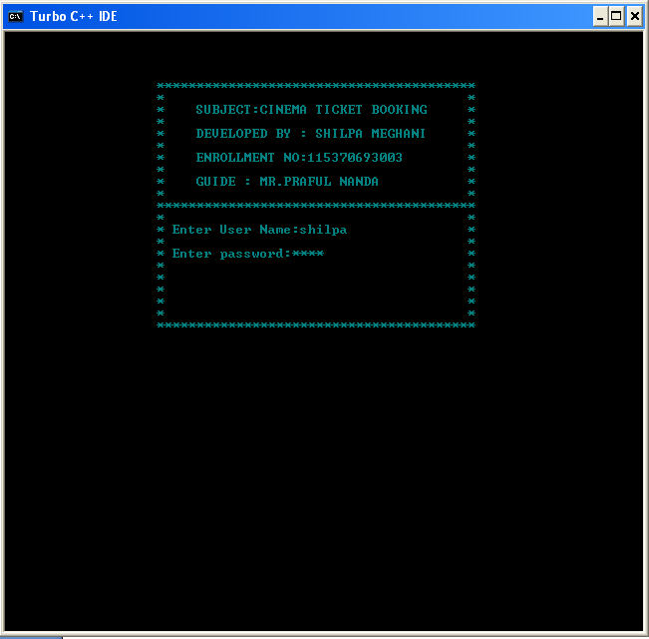

Description:

Login screen is used to verify the user name and password. It checks for the validation. It provides security to the system. If one tries to more than three times for invalid login then will out of the system.

2. Main Menu Screen:

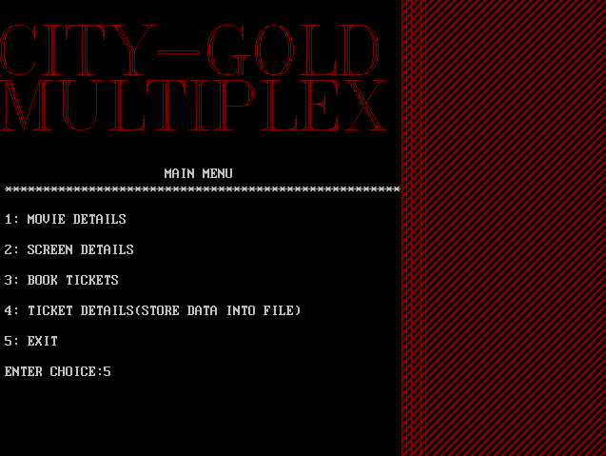

Description:

Main menu screen works like welcome screen for the user.
Main Menu screen provides various selections like movie details, screen details, book tickets and ticket details as per user requirement.

3. Movie Details Screen:
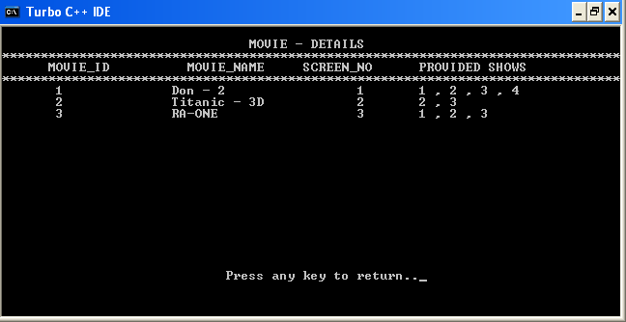
Description:

Movie details screen provides information related to movie to the user like movie_id, movie_name, screen_no and provided shows for particular movie.
3. Screen Details Screen:
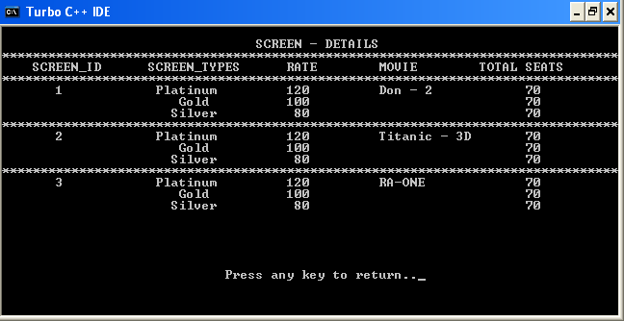
Description:

Screen details screen provides information related to various screen to the user like screen_id, screen_types, rate, movie_name and total number of seats for particular screen(1,2,3) and screen_type(Platinum, Gold, Silver).
4. Booking menu Screen:
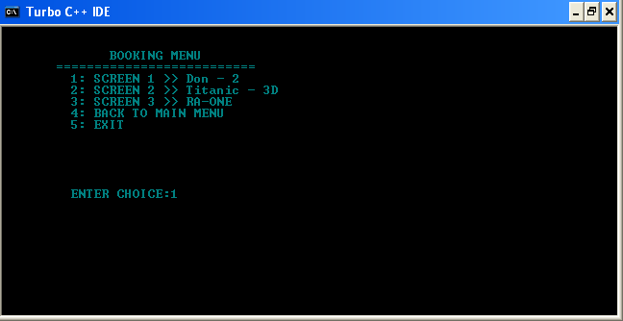
Description:
When user selects the book ticket option it provides the above screen for book the ticket. It provides the booking menu for particular screen with movie_name. user can select the screen 1, 2 or 3.

When user select any one screen from above menu it gives following screen for selection of particular screen type like Platinum, Gold and Silver with rate for the specific screen.

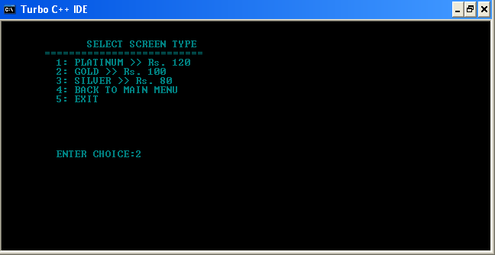
5. Booking menu Screen: 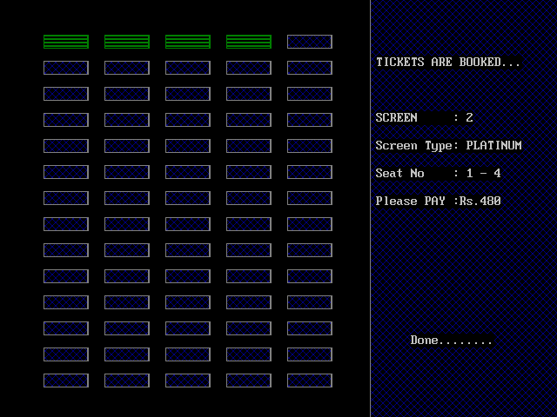
Description:
When user selects particular screen type then ticket booking screen is shown. In it user can enter the number of seats to book. If the seats are available in particular screen it books the tickets and show the Screen name, type, provided seat numbers and final payment.
It also shows process to print the tickets.
6. Ticket Details Screen:
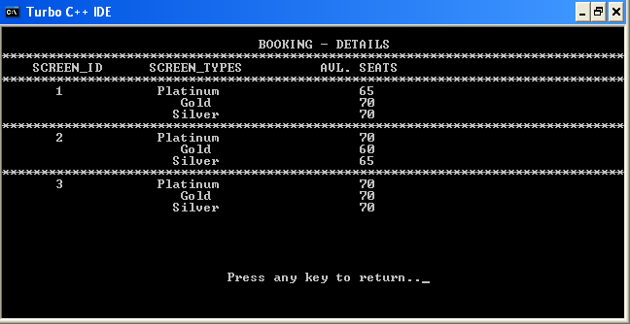
Description:
Booking details screen provides availability of seats for particular screen number and screen type.

Future Enhancement

There are several important features I would like to add to this project but because of Time Limit I cannot include them. I have created this list to help me track these improvements, as well as share with the general public my goals for this project.

- Right now using this project one can book only tickets for the current show but in future we can provide current booking as well as advance booking.

- Facility of ticket cancellation can also provide so the tickets which are cancelled out can give to others.

- Advance booking by the phone of mobile can also possible which provides more user friendly environment.

- Special guideline for the project or help provide to the user in future for better use of the project.

- Seating arrangement for particular screen and screen type can also facilitate to the user.

Bibliography

The Bibliography contains references to all the documents that were used to develop the software.

Books referred:

Serial NO | Book Name | Author
1 | Programming With ANSI C++ | Mr. Bhushan Trivedi
2 | Effective C++ | Mr. Scott Meyers
3 | The C++ Programming Language | Mr. Bjarne Stroustrup
4 | Expert C Programming : Deep C Secrets | Peter Van Der Linden

Websites referred:

Serial NO | Web Site Name
1 | www.cprogramming.com/books.html
2 | http://www.scribid.com/doc
3 | www.google.com
4 | www.cmagical.blogspot.com

